Technology and U.S. Emissions Reductions Goals: Results of the EMF 24 Modeling Exercise
Leon Clarke*, Allen Fawcett**, John Weyant***, James McFarland**, Vaibhav Chaturvedi*, Yuyu Zhou*,

This paper presents an overview of the study design and the results of the EMF 24 U.S. Technology Scenarios. The EMF 24 U.S. Technology Scenarios engaged nine top energy-environment-economy models to examine the implications of technological improvement and technological availability on reducing U.S. greenhouse gas emissions by 50% and 80% by 2050 on the U.S. energy system and economy. The study confirms that mitigation at the 50% or 80% level will require a dramatic transformation of the energy system over the next 40 years. The study also corroborates the result of previous studies that there is a large variation among models in what energy strategy is considered most cost-effective. Technology assumptions are found to have a large influence on carbon prices and economic costs of mitigation.

* Joint Global Change Research Institute, Pacific Northwest National Laboratory. Contributions to this paper by Clarke, Chaturvedi, and Zhou were supported by the Global Technology Strategy Project at the Joint Global Change Research institute/Pacific Northwest National Laboratory.
** U.S. Environmental Protection Agency.
*** Stanford University.

Introduction and Background
It is now well understood that the technology cost, performance, and availability can have a substantial impact on the macroeconomic costs, and the challenge more generally, of meeting long-term global climate goals or national mitigation goals such as those that have been considered in the United States. Although a number of individual studies have specifically explored the role of technology in meeting climate goals in the U.S. (see, for example, Kyle 2009 and Kyle 2011 among others), there exists no coordinated study that explores this space across multiple models and using a coordinated set of model assumptions. The EMF 24 scenarios fill that gap. Nine models produced scenarios for this study, based on three mitigation goals for the United States: no emissions reductions (reference scenarios), a 50% reduction in emissions relative to 2005 levels, and an 80% reduction relative to 2005 levels. These emissions pathways correspond to those explored in the EMF 22 multi-model study (Clarke et al., 2009) and its predecessor (Paltsev et al., 2008). The EMF 24 scenarios then combine these mitigation goals with various assumptions about the availability, cost, and performance of CO₂ capture and storage (CCS), nuclear power, wind and solar power, bioenergy, and energy end use.
This study is motivated by three primary questions. First, how might technological improvements and technological availability influence the character of the U.S. energy system transition associated with 2050 climate mitigation goals? Second, what are the macroeconomic mitigation cost and carbon price implications of meeting 2050 climate mitigation goals, and how are these influenced by different futures of technology availability, cost, and performance? Finally, can 50% and 80% reduction goals for the United States be met largely through the implementation of limited technology portfolios? In particular, can these goals be met based exclusively through end-use measures and renewable energy – that is, without the use of nuclear power and CCS – and vice versa?
The remainder of this paper proceeds as follows. Section 2 introduces the study design for the EMF 24 Technology Scenarios. Section 3 then discusses the nature of emissions and energy system transitions in the reference scenarios. Section 4 then discusses the economic, emissions, and technological characteristics of the mitigation scenarios. Section 5 sums up and discusses directions for future research suggested by the results of this study.

Study design

Overview of the study design
The EMF24 Technology Scenarios were designed to assess how the cost and availability of low-carbon technologies and energy end-use measures might affect the U.S economy and energy system under policies that reduce GHG emissions. The matrix of scenarios in the study consists of a technology dimension and a policy dimension (Table 1). The technology dimension captures variations in technology cost, performance, and availability. The policy dimension captures the two 2050 mitigation goals for the study.

Table 1. Summary description of EMF 24 Technology Scenarios [Note: “Opt” refers to “Optimistic” and “Pess” refers to “Pessimistic. In the companion, policy paper (Fawcett et al., this volume), “Pess Renew” is referred to as “Opt CCS/Nuc”, and “Pess CCS/Nuc” is referred to as “Opt Renew”.]
Technology Dimension
 | Opt Tech | Single Sensitivities |  |  | Combined Sensitivities |  |  | Pess Tech
 | Opt Tech | Pess  EE | Pess  CCS | Pess  Nuc | Pess Renew | Pess CCS/Nuc | Pess EERE | Pess Tech
End-Use Energy | Opt | Pess | Opt | Opt | Opt | Opt | Pess | Pess
CCS | Opt | Opt | Pess | Opt | Opt | Pess | Opt | Pess
Nuclear | Opt | Opt | Opt | Pess | Opt | Pess | Opt | Pess
Wind & Solar | Opt | Opt | Opt | Opt | Pess | Opt | Pess | Pess
Bioenergy | Opt | Opt | Opt | Opt | Pess | Opt | Pess | Pess
Policy Dimension
No New Policy (reference) | X | X | X | X | X | X | X | X
50% Cap & Trade | X | X | X | X | X | X | X | X
80% Cap & Trade |  |  |  |  | X | X

The suite of technologies examined in the study includes end-use energy reduction technologies, CCS, nuclear power, wind and solar power, and bioenergy. For each class of technologies, optimistic and pessimistic sensitivities were specified (Table 2). For nuclear power and CCS, the sensitivities are meant to capture the influence of factors that might affect the availability of these technologies. Hence, the pessimistic sensitivities restrict the deployment of these technologies whereas the optimistic sensitivities allow for expansion. No variation in cost and performance is assumed for these technologies. Based on similar reasoning, bioenergy sensitivities represent variations in the supply of bioenergy. In contrast, sensitivities for wind and solar power capture variations in the cost and performance of solar and wind power. No explicit limitations on expansion were specified for the scenarios. Finally, sensitivities in end-use are meant to capture changes in technology and deployment that would lower end-use energy demands. Because many models do not have structural representations of the end-use sector, the end-use assumptions were specified simply in terms of a reduction in final energy consumption. The means of achieving this reduction was left ambiguous, which raises interpretation issues that are discussed below.

Table 2. Technology Assumptions
Technology | Optimistic Tech | Pessimistic Tech
End-use Energy | End-use assumptions regarding technology that lead to a 20% decrease in final energy consumption in 2050 relative to the pessimistic technology, no policy case. | Evolutionary progress. Precise assumptions specified by individual modeling teams specified by each individual modeler.
Carbon Capture and Storage (CCS) | CCS is available. Cost and performance assumptions specified by individual modeling teams | No implementation of CCS.
Nuclear | Nuclear is fully available. Cost and performance specified by each modeling team. | Nuclear is phased-out after 2010. No new construction of plants beyond those under construction or planned. Total plant lifetime limited to 60 years.
Wind and Solar Energy | Plausibly optimistic technology development. Cost and performance assumptions specified by individual modeling teams. | Evolutionary technology development. Cost and performance assumptions specified by individual modeling teams
Bioenergy | Plausibly optimistic level of sustainable supply. Supply assumptions specified by individual modeling teams. | Evolutionary technology development representing the lower end of sustainable supply. Supply assumptions specified by individual modeling teams.

The EMF 24 Technology Scenarios (Table 1) represent different combinations of technology sensitivities (Table 2). They are bracketed by Optimistic Technology and Pessimistic Technology assumptions, which hold all technologies at their respective optimistic and pessimistic sensitivities. A set of three single technology sensitivities test the effect of switching from optimistic assumptions about end-use, CCS, and nuclear to pessimistic assumptions while maintaining optimistic assumptions for all other technologies. Three combined sensitivities, Pessimistic CCS/Nuc, Pessimistic Renewable, and Pessimistic End-Use Energy and Renewable Energy (EERE) examine the effect of limiting the energy system transition to pathways that rely on particular combinations of technologies. Scenarios based on Pessimistic CCS/Nuc assumptions rely exclusively on end-use reductions and renewable sources, because deployment of CCS and nuclear energy is constrained. Scenarios based on the Pessimistic Renewable assumptions assume the availability of CCS and nuclear energy, but uses less optimistic assumptions about renewable technologies. The Pessimistic EERE technology assumptions add pessimistic assumptions about end-use energy to the Pessimistic Renewable assumptions.
Several observations are important for interpretation of these scenarios. First, although the assumptions across technology categories were chosen to be roughly comparable, in practice this is an imprecise and subjective decision. It is difficult, for example, to assess the likelihood of the end-use energy reductions assumed in this study relative to the constraints on CCS or nuclear energy. Second, with the exception of nuclear and CCS assumptions, the precise of specifications of many of the technology assumptions (e.g., for renewable power) were left to the individual modeling teams, who undoubtedly chose different values. This means that it is difficult to consistently ascertain the implications of, for example, more optimistic wind and solar assumptions. One reason for this decentralized approach was that the models have very different methods of representing these technologies. Third, the costs of achieving Optimistic Technology assumptions are not specified for any of the scenarios. For example, research, development, and demonstration (RD&D) costs are not specified. This means that the cost difference between scenarios based on Pessimistic Technology and Optimistic Technology assumptions is biased toward overestimation in all cases by the additional investment that would be required to reach the Optimistic Technology assumptions. The treatment of end-use measures is particularly ambiguous in this regard. Improvements in end-use efficiency could involve a mix of both improvements in technology and changes in policy—for example, appliance efficiency standards—to spur adoption. The precise role of each of these is unspecified. To interpret the end-use assumptions in a manner that is consistent with the supply-side assumptions, it is necessary to assume that all of the energy end-use reductions occurred because of the availability of new technology with higher efficiency but without additional cost. In addition to the ambiguity of the source of end-use energy reductions, there are known market failures in markets for end-use efficiency that further complicate the welfare costs of implementing energy end-use measures.
All told, then, the differences in results arising from differences between technology assumptions in this study should be interpreted carefully and precisely. On the one hand, it is possible to draw some conclusions about the implications of different technologies at a broad level. On the other hand, these results are highly dependent on assumptions and may miss underlying costs, so precision is limited.
The policy dimension of these scenarios is based on an economy-wide carbon price leading to linear reductions in cumulative emissions of greenhouse gases over the period from 2012 through 2050. Reductions are specified as reaching either 50% below 2005 levels or 80% below 2005 levels in 2050. Banking of allowances is allowed, but borrowing of allowances is not permitted. In cases where models found banking to be cost-effective, the linear pathway was not sufficient to characterize the scenarios, so a cumulative total was required. The emissions cap covers all Kyoto gases in all sectors of the economy that the particular model represents, with the exception of CO₂ emissions from land use and land use change, which are excluded from the analysis. This means that non-CO₂ land use and land use change emissions and emissions of GHGs not covered under many U.S. climate bills are still included in the cap. It is important to note that different models have different capabilities to represent emissions from different sources and sectors (see Table 3), so individual models were asked to define the full scope of their targets to fit the capabilities of the models. In general, this meant that there was a distinction between those models that represent non-CO2 substances and those that don’t.
The balance between the technology and policy dimensions of the study was made by conducting a full evaluation of technology variations for the 50% scenarios and then producing both 50% and 80% reductions for two specific combinations of technology assumptions. To manage the burden on the modelers, it was not feasible to produce the full range of technology variations for both the 80% reduction scenarios in addition to the 50% reduction scenarios. The two technology combinations chosen for the 80% scenario were chosen to explore the implications of (1) focusing the energy system solution largely on renewable energy and price-induced reductions in energy demand by specifying pessimistic assumptions for nuclear and CCS (Pessimistic CCS/Nuc) or (2) biasing the solution toward nuclear and CCS, along with price-induced reductions in energy demand, by specifying pessimistic assumptions for renewable energy while allowing for expansion of nuclear energy and CCS (Pessimistic Renewable). In both of these cases, optimistic assumptions were used in energy end-use to allow for a clearer comparison of the effects of the different supply-side options.
To define consistent policy architectures across the models, additional specifications were made in the areas of international emission reductions, bioenergy trade, offsets, and banking and borrowing. For global models, the rest of the world follows emission reduction paths that are similar to U.S. reductions in developed countries and considerably slower in developing ones. Trade in bioenergy is limited by design to isolate U.S. bioenergy activity. Domestic and international offsets were not allowed. The precise assumptions for the EMF 24 Scenarios, in the form of the final specifications presented to the participating modeling groups, are provided in the Supplemental Material for this paper.

Participating Models
Nine models participated in this study. These models differ in a number of ways that can have important implications for the resulting scenarios (Table 3). Models vary in their sectoral coverage, with the core sectors of interest being the energy sector, land use, and the rest of the economy. In general, models are designed to focus on breadth or on depth. For example, some models may represent only the energy or electricity sector and put substantial focus on capturing the details of that sector; others may represent the full economy with the focus on capturing the interactions between sectors. Models that represent the full economy are capable of producing a broader suite of economic indicators, including consumption losses and GDP effects. Models without a full economy typically represent costs in terms of area under the marginal abatement cost function or total system costs. Models vary in their regional resolution, with many models representing the U.S. as a single region, others representing roughly ten subregions, and one model representing over a hundred separate regions. The variation in covered gases, as noted above, influences how the models represented the mitigation targets. Some models represent all covered gases, whereas others focus only on CO2. Models capture the time dimension in different ways as well, including the last historical year in the model (the base year) and the time steps of the model (ranging from two years to ten years). It is important to note no model included a base year of 2012, which means that 2012 was a projection year in all of the models in this study. The representation of technology choice is one important factor in the way that models represent technology. Some models used probabilistic approaches to technology choice among discrete technologies, others use production functions, and still others use linear and non-linear optimization methods among discrete technologies. The models also vary in the way that they represent foresight. Models generally fall into two categories: dynamic-recursive models, which assume that all decisions are based on current conditions, and perfect foresight models which assume that decision-makers have a complete view of the future when they make decisions. One model applies a combination of these two, with limited foresight. Finally, the option to deploy CCS with bioenergy is an important technology for these scenarios, because it can lead to negative emissions. Mot models assume that this technology will not be available.

Table 3. Overview of Key Characteristics of the Versions of Participating Models Used in EMF 24.
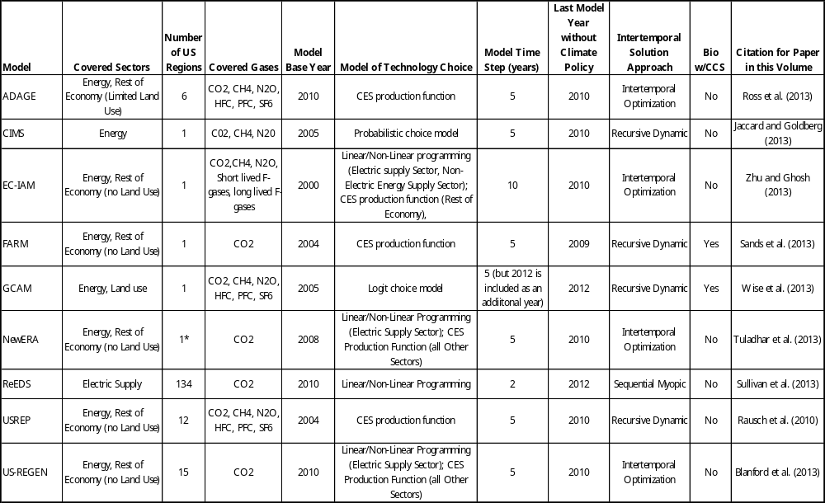
[*Note that at the time that the EMF 24 runs were produced, NewERA included only a single U.S. region. The current default version includes 12 U.S. regions.]

Energy, Technology, and Emissions in the Reference Scenarios
Reference (or no policy) scenarios serve several roles in studies such as this. One role of reference scenarios is that they serve as a counterfactual starting point for the application of policies. It is therefore important to understand the nature of the reference scenarios as a basis for insight in the behavior of the mitigation scenarios, which are the focus of this study. Differences in reference scenarios can lead to differences in the characteristics of mitigation pathways. For example, higher emissions in the reference scenario will require greater emissions reductions in the mitigation scenarios. Another role of reference scenarios is to provide a window into the uncertainty surrounding key drivers – for example, population growth, economic growth, and resulting emissions and energy pathways – that influence the behavior of the mitigation scenarios. Different modeling groups develop different estimates of the drivers of emissions. The fact that assumptions and reference results vary among groups derives from our collective lack of knowledge about how these key forces might evolve forty years into the future. The variation in reference assumptions and results, however, are not a full representation of uncertainty, particularly since modeling teams may base their projections of key parameters on common sources of projections. Nonetheless, they still provide some insight into our lack of knowledge about the future (see Krey and Clarke, 2011 for more on this topic). A third role of the reference scenarios in this study in specific is that they provide insights into the impact of technology on energy demand and emissions in the absence of an explicit climate policy.

Population and GDP
One of the main determinants of future energy demand and emissions is population growth, which correlates both to the supply of labor and the demand for goods and services (Figure 1). The population projections used in the models assume that the US population will add between 89 and 138 million people by 2050. The associated compound annual growth rates from 2010 to 2050 range from 0.6 to 0.9 percent per year. All of these assumptions are below population growth in the U.S. over the last 40 years, which stood at an annualized rate of 1 percent. These population projections are not characterized by substantial variation; all fall within +/-5 percent of the mean value of 420 million in 2050. All other things being equal, this lack of significant variation in the population estimates would tend to dampen variation in key characteristics of the mitigation scenarios, such as policy costs. For comparison, the population projections are roughly bounded by population estimates from the United Nations (UN) and the US Census Bureau. For the lower bound, the UN, in its medium variant case projects the US population at 400 million in 2050 (UN 2009). At the upper end, the US Census Bureau’s 2050 projection is 439 million, which is close to the UN’s high variant case (US Census 2008).

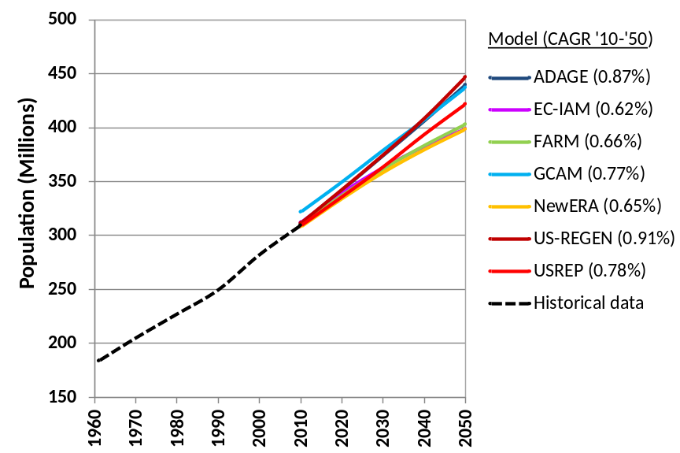
Figure 1. Population assumptions across models. [Note: CAGR refers to cumulative annual growth rate.]

The level of economic activity, as measured by gross domestic product (GDP) (Figure 2), is a major driver of energy consumption. GDP can be an explicit input to models or it can be calculated within the models. However, even in the latter case, GDP is primarily driven by two or three primary input assumptions, including labor force, labor productivity, and technological change, and is generally implicitly calibrated to expectations. This means that reference GDP lies somewhere between an input assumption and a model result even in models in which it is calculated endogenously. Changes in GDP from policy or technology changes, in contrast, are an important output of many models.
The compound annual growth rates across the models from 2010 to 2050 are between 1.8 and 2.6 percent under the Optimistic Technology assumptions. These growth rates are slower than historical rates. The annual GDP growth rate in from 1950–1990 was 3.5 percent and declined to 3.1 percent from 1967 to 2007. Across the models, the growth rates tend to fall by up to a few tenths of a percent each decade. GDP shows a greater degree of variation than population across the models. By 2050 the average GDP across model projections reaches $32 trillion with a spread of $10 trillion, or +/- 17 percent of the mean.

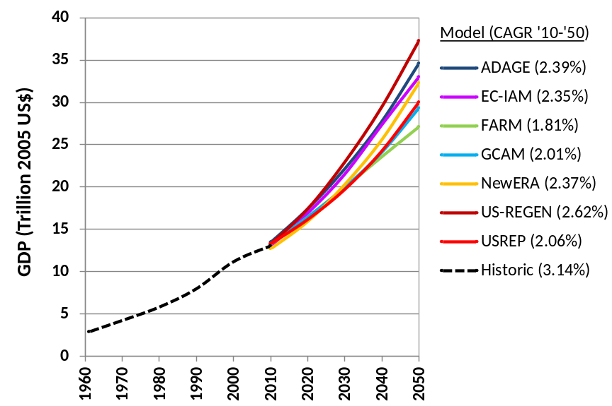
Figure 2. GDP projections across the models, Optimistic Technology reference scenario. [Note: CAGR refers to cumulative annual growth rate.]

Of particular interest for the discussion here is that GDP can be influenced by technology assumptions for the “general equilibrium” models participating in this study – those that represent the full economy in Table 3 (Table 4). The particular end-use energy assumptions used in this study have the largest influence on reference GDP in these scenarios. Although tempting, it is not possible, given the structure of the study, to conclude that energy use technologies are more valuable in the absence of carbon policy than supply technologies. A primary reason for this is that there is no cost associated with achieving the assumed level of energy use improvements (roughly 20% reduction), nor is there clarity on the associated issue of whether they occurred purely through the availability of new technology or by end-use-focused policies. (See Section 2.1 for a more thorough discussion of interpretation of technology assumptions).
At the same time, it is clear that more optimistic assumptions of the low-carbon energy supply have only a limited influence on GDP in the reference scenarios. Their effects are felt most strongly in the presence of a price on carbon. Without a price on carbon, there is little incentive to increase the deployment of these technologies substantially enough to dramatically alter the energy system (see Section 3.2) and influence GDP.

Table 4. Percentage change in reference scenario GDP relative to the reference scenario with Optimistic Technology assumptions in 2020 and 2050
 | 2020 |  |  |  | 2050
 | Pess. Renew | Pess. CCS/ Nuc | Pess. EERE | Pess. Tech | Pess.  Renew | Pess.  CCS/ Nuc | Pess.  EERE | Pess. Tech
ADAGE | 0.0 | 0.0 | -0.3 | -0.3 | 0.0 | 0.0 | -1.2 | -1.2
EC-IAM | 0.0 | 0.0 | -0.1 | -0.1 | 0.0 | -0.1 | -0.5 | -0.8
FARM | 0.0 | 0.0 | -0.7 | -0.7 | 0.0 | 0.0 | -1.7 | -1.7
NewERA | 0.0 | 0.0 | 0.1 | 0.1 | 0.0 | 0.0 | 0.4 | 0.3
US-REGEN | 0.0 | 0.0 | -1.0 | -1.0 | -0.1 | 0.0 | -2.2 | -2.2
USREP | 0.0 | 0.0 | -0.5 | -0.5 | 0.0 | 0.0 | -1.9 | -1.9

Energy Consumption
Consistent with the discussion of GDP effects, the particular assumptions about energy end-use in this study have a larger effect on total primary energy demand and total electricity demand in the reference scenarios that does the variation in energy supply technology assumptions (Figure 3 and Figure 4). As noted previously, this result is largely a matter of construction, since the optimistic end-use assumptions were constructed explicitly to result in roughly a 20% reduction in energy demand relative to the Pessimistic Technology reference case (see Section 2.1). The different modeling teams produced these assumptions in different ways, so that the actual variation between the Optimistic Technology and Pessimistic Technology reference scenario demands ranges across models from between 8% and 24%.
The effects of the energy supply assumptions follow intuition in terms of direction. Not surprisingly, the Pessimistic Renewables assumptions lead to less renewables than the corresponding Optimistic Technology assumptions, and the Pessimistic CCS/Nuc assumptions lead to less nuclear than the corresponding scenarios with Optimistic Technology. Because the accounting of primary energy is conducted in direct equivalents rather than primary equivalents in Figure 3, less optimistic technology assumptions lead to an increase in primary energy in many of the scenarios. This is simply an artifact of the fact that the pessimistic technology assumptions lead to less nuclear and renewable electricity, which is replaced by fossil fuels. With direct equivalent accounting, fossil electricity represents higher primary energy than nuclear and renewable electricity.
More generally, a notable characteristic of all the reference scenarios is that fossil fuels continue to dominate the energy system and the electricity system in specific even under the more optimistic technology assumptions. None of the models indicate that these assumptions will be sufficient to bring about the changes necessary to reduce emissions on the order of 50% or 80% as explored in this study. In addition, the mix of fossil fuels is more dependent on the model and its attendant assumptions than on the assumptions that were employed to capture different levels of low-carbon supply technology. That is, particular models tend to lead to a particular mix of fossil fuels that remains similar across technology assumptions. Both the quantity of fossil energy and the mix of fossil energy are fundamental to the determination of reference scenario CO₂ emissions. All other things being equal, models with higher quantities of coal lead to higher emissions. Of interest, few models project a dramatic expansion of natural gas in the scenarios. One might expect an evolution in reference scenarios produced over the coming years by the models in this study toward natural gas if U.S. gas potential and production continues to play out at the scales that are being suggested.

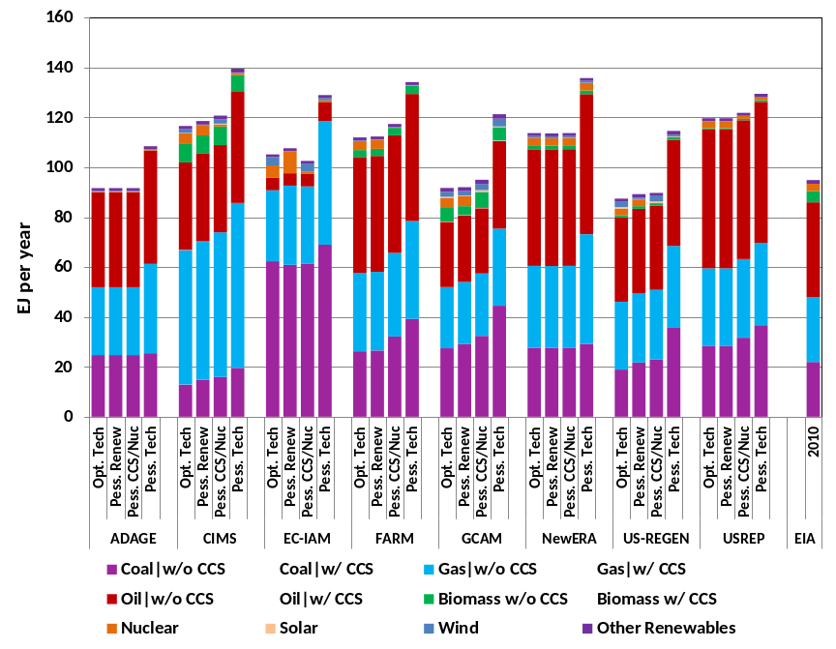
Figure 3. Total primary energy consumption (direct equivalents) in reference scenarios in 2050 by source and technology assumptions.
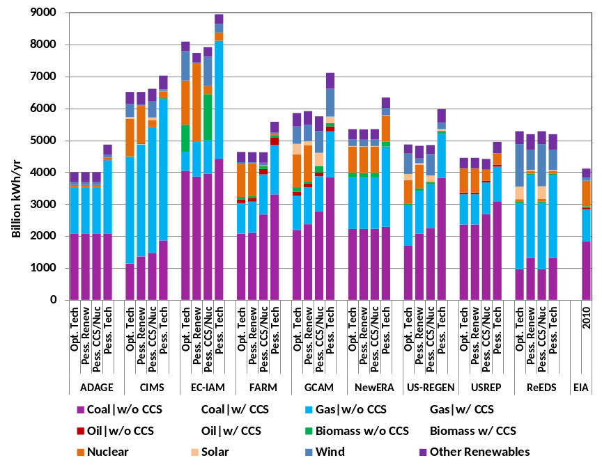
Figure 4. Electricity generation in reference scenarios in 2050 by technology assumptions.

Greenhouse Gas Emissions
Consistent with the lack of low-carbon penetration into the energy sector discussed in Section 3.2, no reference scenario in this study meets the mitigation goals of the study. Even under Optimistic Technology assumptions, the most aggressive emissions reduction from any of the models is -0.19% per year through 2050 (Figure 5 and Figure S.1 in the supplementary material for this paper). Although self-evident, this observation is important because it further reinforces the notion that it is unlikely that technology alone will be sufficient to meet aggressive climate goals. Climate policy is needed to reduce emissions in a meaningful way. In the results from this particular study, the benefit of technology is largely to alter the challenge of meeting long-term mitigation goals.
The variation in reference scenario emissions tends to follow the variation in energy production quite closely, and therefore follows the same logic. That is, the end-use assumptions have the largest influence on reference scenario emissions and there is substantial variation across models in terms of reference scenario emissions. Although not shown here, the variation in supply technology assumptions does not lead to as large a variation in emissions as the variation in the models and their attendant assumptions. The electricity and transportation sectors together account for over half of total emissions by 2050 in all models, as is the case today (Figure 5). This is an artifact of the fact that the building sector and the industrial sector both make extensive use of electricity, which means that much of the emissions consequences of these sectors are mediated through electricity production.
In addition to the different sizes and characters of the energy systems across models and scenarios, one reason for variation in 2050 among the models is that they begin at different starting points in 2010. A large portion of the variation is due to differences in the gases covered by the different models. Those models that track only CO2 emissions fall well below those that track additional GHGs. A second reason for the difference is that models start from different points in time (see Table 3), so that 2010 is a projection year for all models in this study. In general, none of the models effectively represented the recent reduction in CO2 emissions.

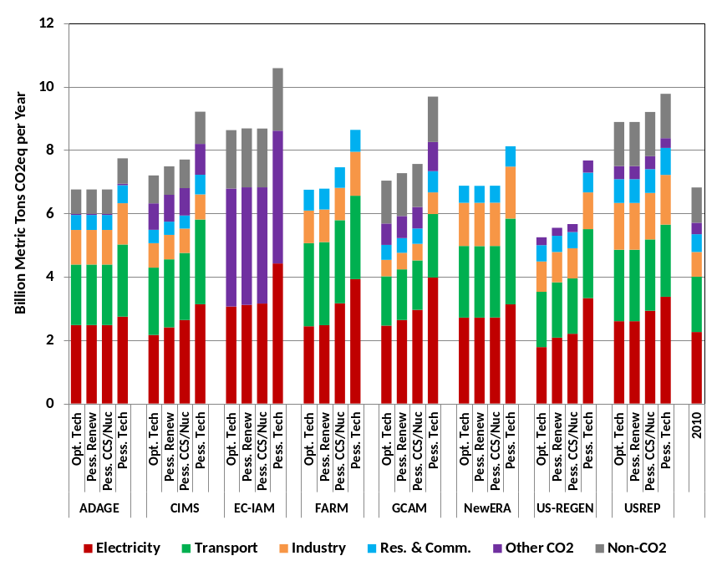
Figure 5. GHG emissions in reference scenarios in 2050 by sector and by technology assumptions.

Climate Policy Scenarios

Emissions pathways and the feasibility of emissions reductions targets
A broadly important result of the mitigation scenarios is that every model could produce every scenario in the study. This means that they were able to meet 50% reductions even under the most pessimistic assumptions about technology. It also means that every model was able to produce the 80% reduction scenarios without nuclear and CCS; that is, relying exclusively on renewable energy and end-use measures. Conversely, every model could produce all mitigation the scenarios based on less optimistic assumptions about renewable energy. To be clear, however, this ability of models to produce scenarios is not sufficient to draw conclusions about the “feasibility” of these scenarios in a more applied sense. The ability or inability of models to produce scenarios is a useful input to discussions of feasibility. However, judgments of feasibility are ultimately bound up in subjective assessments of whether the U.S. (in this case) would be willing and capable of taking on the transformation required to meet the mitigation goals, including bearing the associated macroeconomic costs and undergoing the required technological, institutional, and social transitions.
Three important questions regarding mitigation are (1) from which sectors will emissions reductions come from in an economically-efficient approach to mitigation, (2) which sectors might undergo the largest transitions, and (3) which sectors might ultimately prove the most challenging for mitigation. The relative distribution of emissions reductions across sectors (Figure 6 and Figure 7) provides a window into these questions. Across scenarios, electricity constitutes the largest single contributor to emissions mitigation across models, and electricity undergoes a substantial transformation through 2050. For example, most models reduce electricity by 75% or more by 2050 in the 50% reduction scenarios under Pessimistic Renewable assumptions. The role of electricity in these scenarios supports the notion that electricity is the least-challenging sector to decarbonize directly so it takes on the largest initial emission reductions (see, for example, Edmonds et al., 2006). However, it is also important to remember that not all these reductions arise from changing to low-carbon supply options. The price on carbon also leads to reductions in electricity use in end uses, which lowers electricity sector emissions (technology transitions in the electricity sector are discussed in Section 4.3).
Because emissions from electricity are so substantially reduced in the 50% scenarios, there is relatively little remaining room for additional emissions reductions from that sector to meet the 80% goal in most models. For this reason, the bulk of the additional emissions reductions come from non-electric sectors, which require increasingly higher costs. Exceptions to this include FARM and GCAM, which rely upon bioenergy coupled with CCS in the electric sector. With this technology, the electric sector serves as a carbon sink moving from the 50% to the 80% scenario; that is, emissions are reduced beyond 100%. This limits the necessity to reduce emissions from other sectors at deeper levels of emissions reduction. Under the Pessimistic CCS/Nuc assumptions, ADAGE, NewERA and USREP also find additional, substantial reductions from the power sector.

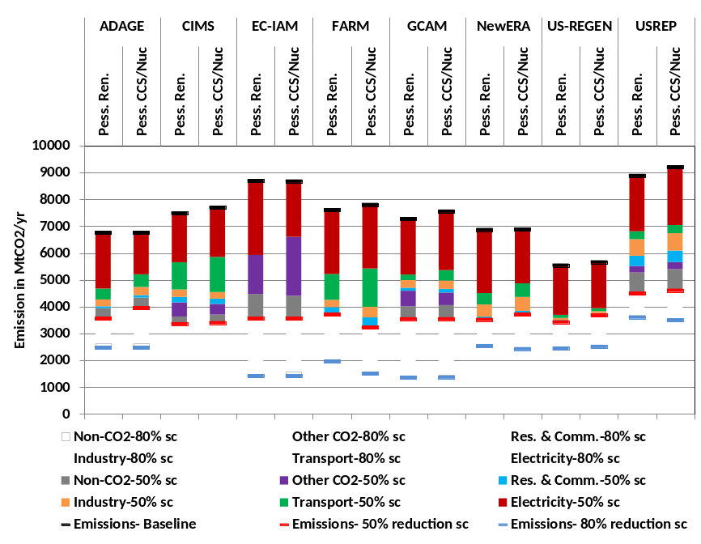
Figure 6. Emission reductions from the corresponding reference scenario in 2050 by sector in 50% and 80% scenarios for Pessimistic CCS/Nuc and Pessimistic Renew technology assumptions.
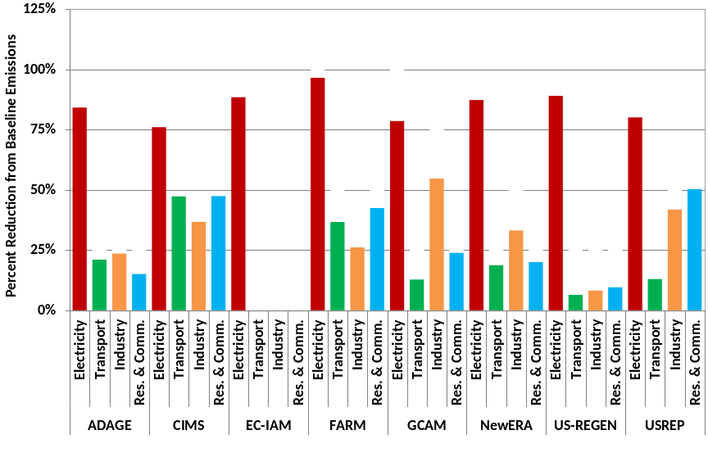
Figure 7. Direct emissions reductions in 2050 by sector under Pessimistic Renewables assumptions. Solid bars represent sectoral reductions for the 50% cap; hashed bars represent the additional reductions for the 80% cap.

A salient question for understanding the strategy for mitigation in the U.S. is whether mitigation in the energy sector takes place more through reductions in the emissions intensity of energy or reductions in the energy intensity of GDP. The relationship between these provides a perspective on the relative roles of end-use energy reduction (associated with the change energy intensity of GDP) and the deployment of low-carbon energy and fuel switching to better utilize lower carbon fuels (reflected in the change in emissions intensity of energy). Historically, evolution in the energy sector over the last fifty years largely involved reductions in the energy intensity of GDP, with only modest reductions in the carbon intensity of energy (Figure 8 and Figure S2 in the Supplementary Material). The reference scenarios continue this trend, exhibiting a decline in the energy intensity of economic activity from about 8 MJ/$ today to between 3-5 MJ/$ in 2050 with very little change in the emissions intensity of energy over this time.
This behavior is largely reversed in the mitigation scenarios. The primary means of additional emissions reductions is to alter the mix of primary energy. Under Pessimistic Technology and Optimistic Technology assumptions with a 50% emissions reduction, the energy intensity falls to 2-4 MJ/$. Emissions intensity of energy consumption declines from roughly 60 kgCO2/GJ to between 20 and 50 kgCO2/GJ. To put those numbers in the context of fossil fuels, the average carbon content of energy consumption would be similar to natural gas and up to roughly 50% lower.

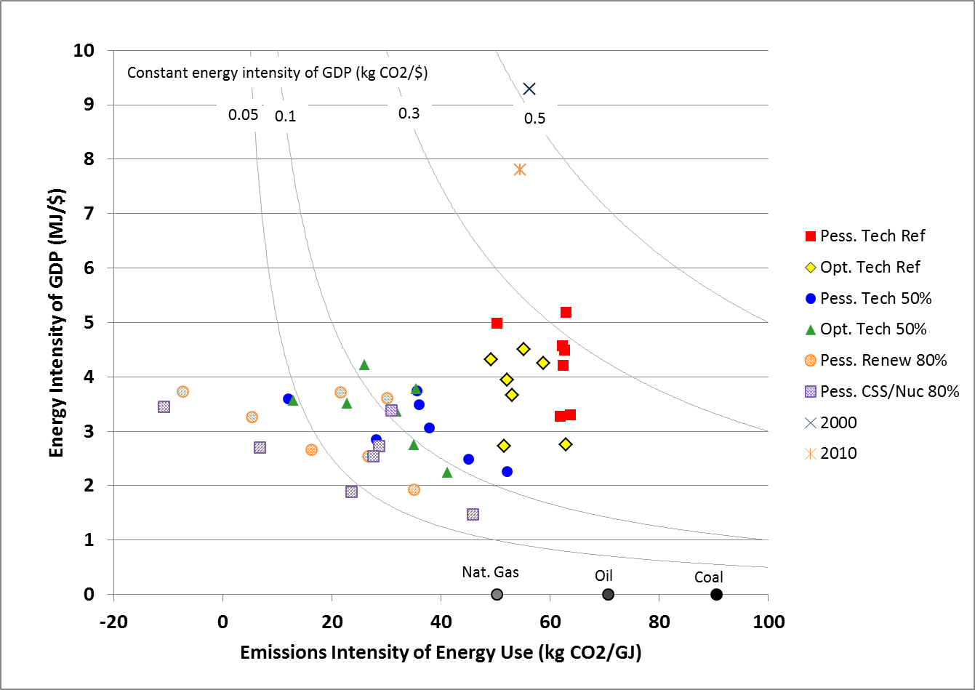
Figure 8. Energy intensity of GDP vs. emissions intensity of energy in 2050 (fossil equivalents) for different technology assumptions and emissions reduction levels.
In addition to affecting emissions pathways across sectors and energy and emission intensities, technology availability also alters the emission reductions pathways over time (Figure S3 and Figure S4 in the Supplementary Material). The effect of technology on banking behavior is of particular interest. Recall that the cumulative reduction targets are based on a straight-line emissions pathway. The ability to bank emissions lowers overall policy costs by equalizing the marginal reduction costs over time. A bank of emission permits is built in the near-term when the policy target is less stringent and marginal reduction costs are lower. As the emissions constraint becomes more stringent over time and marginal reduction costs rise, banked permits are used to meet part of the reduction target. The level of banking differs substantially across models. However, banking is greater across all of the models under Pessimistic Tech assumptions than under Optimistic Technology sssumptions. With fewer low-cost mitigation options in the future, the models rely more heavily on near-term reductions as a strategy to lower overall costs. Banking is also greater in the 80% reduction scenarios than in the 50% reduction scenarios.

Technology and the costs of mitigation
The costs of mitigation are influenced not only by the mitigation goals, but also by the technologies available for mitigation. One common economic indicator of cost is the price of carbon at different points of time (Figure 9). An important caveat in interpreting the carbon price is that it is not an actual metric of total costs. It gives only the marginal cost, and depending on the shape of the marginal abatement costs function, the variation in prices with different levels of mitigation could be very different than the variation in total costs. Measures of economic impacts that are more reflective of total costs include effects on economic output or mitigation cost expressed as consumption loss, equivalent variation, or area under the marginal abatement cost function (Figure 10 and Table S1, Figure S5, and Figure S6 in the Supplementary Material). Models have different capabilities to calculate these various metrics, so an assessment of costs generally must include different metrics across models.

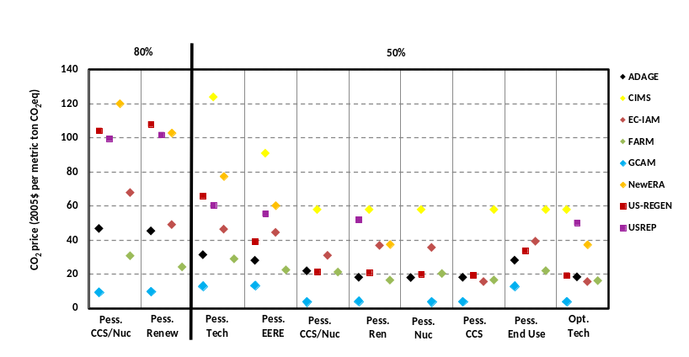
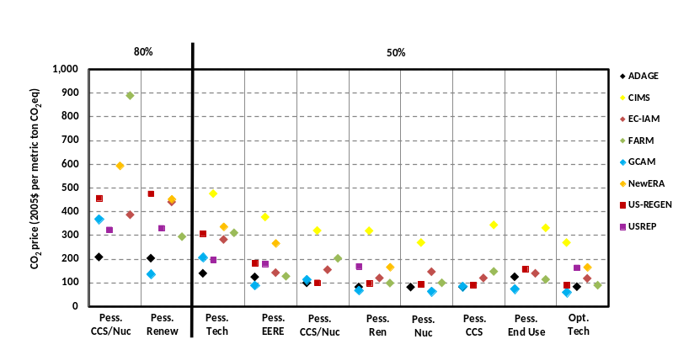

Figure 9. Emission prices across models and scenarios in 2020 (top panel) and 2050 (bottom panel)
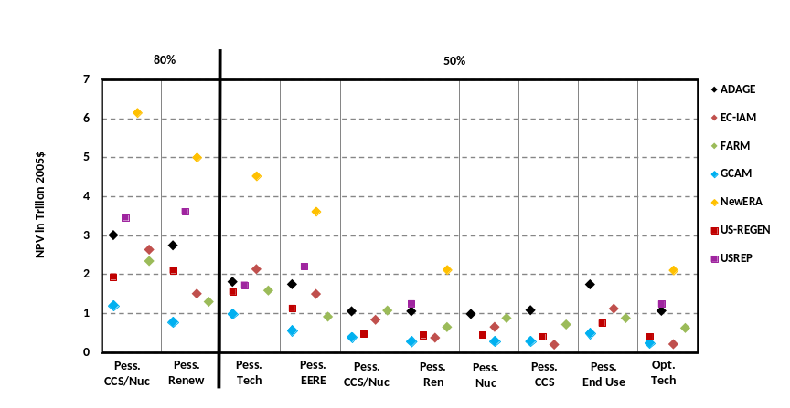
Figure 10. Net present value of mitigation costs from 2010 to 2050.
It is important to note that all of these cost metrics are influenced by the presence or absence of other policies. For example, the presence of regulatory policies to reduce energy consumption will lower the carbon price below what it would be in the absence of these additional policies. It will also lower the total costs of mitigation if the costs of these additional policies are not included in the total cost calculations. A proper cost accounting should take into account the costs of these additional policies as well (see Fawcett et al., 2013, this volume for a further discussion of the implications of combining carbon prices with other policy measures). The interpretation of the difference between scenarios with pessimistic end-use assumptions and those with optimistic end-use assumptions is particularly ambiguous in this regard. Because the means of obtaining these end-use reductions is not specified, the change in the carbon price and the total cost metrics associated with the different levels of end-use technology may not be reflective of the full cost of those scenarios. If the improvement in end-use technology is assumed to result exclusively from improvements to technology, as opposed to policies that lead to their deployment, then cost metrics will be reflective of the total impact of obtaining these energy reductions. (Note, as well, and as discussed in Section 2.1, that the costs of improving technology, for example through R&D, are not included in any of the results presented here and also that there are a range of market failures in markets for technology adoption in end-uses that make interpretation of cost implications of end-use policies challenging.) More broadly, the issue of complementary policies is relevant to all scenarios in this study to the extent that existing policies, such as building standards and CAFE standards, are already in place and influencing energy demand. The cost metrics in this study reflect only the costs in addition to those from policies already in place.
These caveats notwithstanding, several insights emerge from the scenarios. First, the models provide very different estimates of both prices and costs, and this variation across models is larger than the variation in costs within models and across technologies. The variation in economic metrics across models is an outcome of every multi-modeling study to date (see, for example, Calvin et al., 2012, Clarke et al., 2009, and Clarke et al., 2007, among others). It has proven challenging to disentangle the relative roles of model structure and model assumptions in leading to this variation. Diagnosing the reasons for the substantial differences in the economic indicators from models more generally is an important area of continuing research. What is clear from this study is that controlling for several key technology assumptions, such as limiting the deployment of nuclear power and CCS, is not sufficient to obtain convergence in model estimates of costs.
That said, for the 50% reduction scenarios, and under the most pessimistic (most optimistic) assumptions about technology, carbon prices in 2020 fall between $20/tCO2 and $80/tCO2 ($10/tCO2 and $40/CO2) in most models. As a comparison, the carbon prices in 2020 for a similar 50% reduction policy target in the EMF 22 study (Fawcett et al., 2009) were between $25/tCO2 and $70/tCO2. The net present value of economic costs through 2050 under the most pessimistic (most optimistic) assumptions about technology fall between $1 trillion and $2 trillion (less than $1 trillion) in most models. GDP in 2050 is reduced by between 2% to 4% (0.5% to 1.5%) below what it would otherwise be in most models that produce this metric under the most pessimistic (most optimistic) assumptions about technology. For the 80% scenario with either Pessimistic CCS/Nuc assumptions or Pessimistic Renewable assumptions, carbon prices in 2020 in most models fall between $20/tCO2 and $120/tCO2, total mitigation costs through 2050 fall between $1 trillion and$4 trillion, and GDP is 3% to 5% lower than it would otherwise be.
Given the variation in absolute costs among models, it is useful to explore how costs change within models across technology assumptions and mitigation goals as a way to understand the relative importance of different technologies in the mitigation portfolio (Figure 11 and Figure 12). Moving from the Pessimistic Technology portfolio to the Optimistic Technology portfolio reduces carbon prices associated with meeting a 50% goal by roughly 20% to 70%; it reduces the total costs of meeting a 50% constraint by about 20% to over 90%. Moving to the 80% reduction goal increases carbon prices costs substantially.
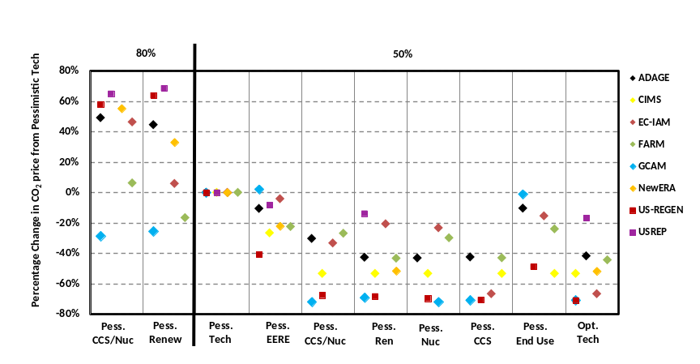
Figure 11.Emissions prices across scenarios in 2020 relative to prices under Pessimistic Technology assumptions and for a 50% emissions reduction.
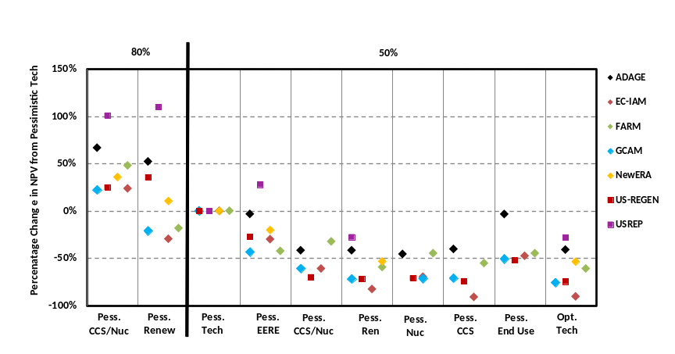
Figure 12. Percent change in NPV of mitigation costs relative to costs under Pessimistic Technology assumptions and for a 50% emissions reduction.

At the levels of reduction considered in this study and with the models used in the study, there does not appear to be any clear technological winner among the different options. Removing nuclear energy, removing CCS, or taking on less optimistic assumptions about renewable energy all have comparable effects on costs, depending on the model. To a large degree, this reflects the notion that there are multiple options for mitigation in the electricity sector, the most important sector for mitigation in the 2050 window, particularly in the 50% scenarios, as discussed above, so the removal of any single option can be made up for by bringing more of other options on line. This result could be different were the study design to call for even deeper reductions than it does. For example, there is evidence that bioenergy coupled with CCS is a disproportionately valuable technology for global mitigation scenarios leading to ambitious goals such as 450 ppmv CO2-e by allowing concentrations to exceed (“overshoot”) the long-term goal and that require extraordinarily deep and rapid emissions reductions, particularly in the second half of the century (see, for example, Clarke et al., 2009).
One of the key factors that might influence mitigation costs is the level of emissions in the reference scenarios. Higher emissions in reference scenarios require deeper reductions to meet the goals in this study, because these goals are expressed relative to 2005 rather than relative to reference scenario emissions. This behavior can be partially visualized in the context of marginal abatement cost functions (Figure 13 – see also the companion paper, Fawcett et al., this volume for more on this topic). In general, the scenarios indicate that reference scenario emissions have an important influence on the carbon prices and associated costs of abatement, in the trivial sense that for any given model, larger reductions are associated with larger prices. However, the variation among models in ability to reduce emissions is of far larger concern. For example, under Pessimistic CCS/Nuc assumptions, the model with the highest reduction from reference emissions in the 80% scenario has only the fourth highest carbon price associated with meeting the target. There is substantial variation in carbon prices for any given level of reduction from reference scenario emissions.

Pessimistic Renewables  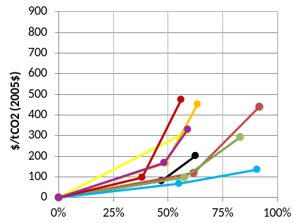 | Pessimistic CCS/Nuc  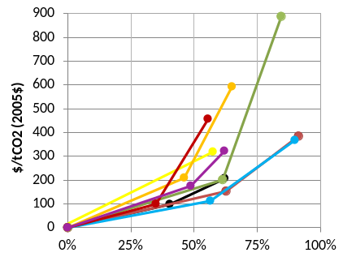
Figure 13. Emissions prices in 2050 relative to percentage emissions reductions from the reference scenario under Pessimistic Renewable and Pessimistic CCS/Nuc technology assumptions. The first dot for each line represents emissions reductions and prices for the 50% reduction scenario. The second dot represents the emissions reductions and prices for the 80% reduction scenario.

Technology and the evolution of the energy system
Mitigation will potentially require a substantial scale-up in low-carbon energy from today’s levels (Figure 14 and Figure 15).The degree of scale-up depends heavily on the size of the energy system in the reference scenario and the degree of energy reductions in the mitigation scenarios. On the higher end of this spectrum, the amount of low-carbon energy by 2050 is upwards of 4 times today’s levels for the 50% and the 80% reduction goals. On the other end of the spectrum, with substantial demand reductions, low-carbon energy is kept at roughly 2010 levels in 2050, even in the 80% reduction scenarios. It is important to note that the scenarios with lower low-carbon energy deployment levels are all scenarios with roughly 50% reductions or more in primary energy consumption relative to reference scenarios without the Optimistic Technology assumptions for energy end-use, with one scenario reaching roughly 75% reductions in primary energy consumption.
In general, the presence of CCS and nuclear energy leads to somewhat higher primary energy on a direct equivalent basis than is the case without these technologies and more optimistic assumptions about renewable power. However, as with economic costs, the largest different between scenarios is generally among models rather than among scenarios within a model. Some models rely heavily on end-use reduction, whereas others rely more heavily on the use low carbon energy. Two models rely heavily on the use of bioenergy coupled with CCS to produce negative emissions. Not surprisingly, without CCS or new nuclear power, scenarios rely more heavily on renewable energy. Conversely, with CCS and nuclear power, but with less optimistic assumptions about renewable energy, the scenarios rely more heavily on CCS and nuclear power. Consistent with previous studies (Edmonds et al., 2006), several studies find that mitigation increases electricity production as low-carbon electricity substitutes for liquid, solid, and gaseous fuels in end-uses.
More generally, the variation in energy system response among models reaffirms two important characteristics of our understanding of energy system responses to climate mitigation. The first is that there are many different pathways that can lead to the same long-term mitigation goal. The second is that there is sufficient uncertainty about technology and relative mitigation potential among sectors that modelers can come to very different conclusions. Key areas where modelers have made different choices include the ability to switch fuels in end-uses, the options for energy use reductions including both reductions in service and the potential for improved efficiency, the relative costs and performance of supply technologies, the manner in which intermittent technologies can be incorporated into the grid, and societal perceptions regarding specific technologies such as nuclear power. Many of these assumptions are explicit in assumptions about technologies or elasticities that are entered into the models, but others are more implicit in the structures of the models or the parameters that result from their calibration or constraints that are entered into the models. It was beyond the charter of the EMF 24 study to attempt to collect this information; however, more sophisticated diagnostics of the representation of technology is an important area for future research.
It is also important to emphasize that these models are searching for a pathway that will minimize the costs of mitigation. One hypothesis is the different pathways, as represented within any single modeling framework, may not have costs that are all that different; that is, there is a flat optimum. To some degree this hypothesis is confirmed by the fact that modest changes in the set of available supply-side technologies – say between the Pessimistic Renewable and Pessimistic CCS/Nuc assumptions – did not result in dramatic changes in the costs of abatement or the carbon price in many models. If the competition is close between technologies, then other societal priorities (e.g., energy security, local environmental concerns) may have an outsized influence on the precise choice of energy system configuration (Clarke et al., 2012, Krey et al., 2013).

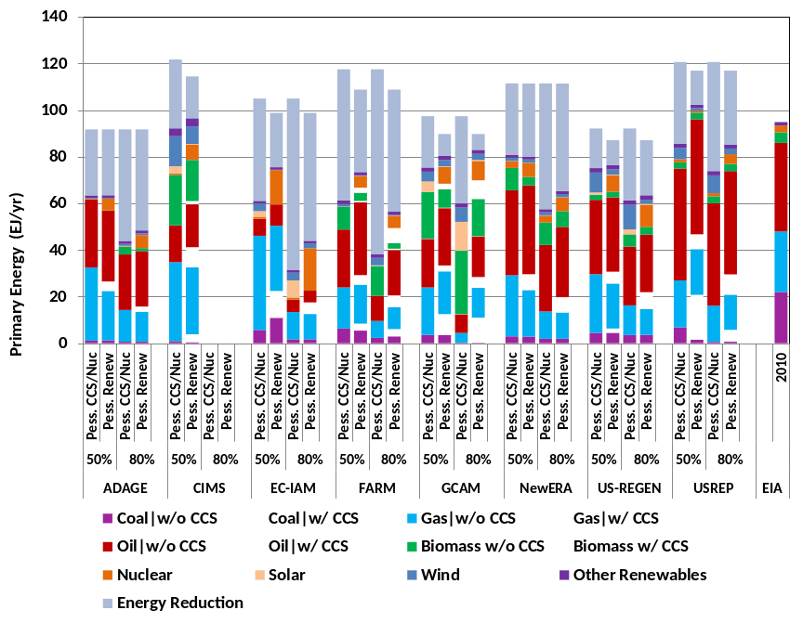
Figure 14. Primary energy consumption in 2050 in the 50% and 80% reduction scenarios for Pessimistic CCS/Nuc and Pessimistic Renewable technology assumptions.
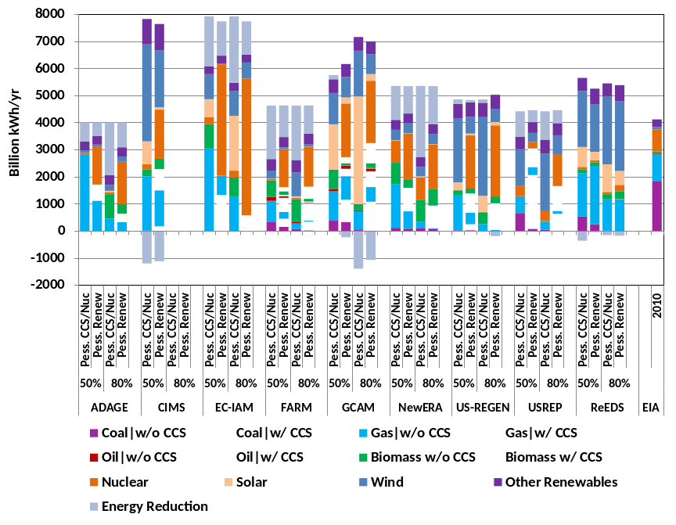
Figure 15. Electricity Generation in 2050 in the 50% and 80% reduction scenarios for Pessimistic CCS/Nuc and Pessimistic Renewable technology assumptions.

Conclusions
The EMF 24 scenarios were motivated by the goal of exploring the implications of technology on the energy transitions and the macroeconomic costs of mitigation in the U.S. They were also motivated by the question of whether it is possible to achieve aggressive mitigation goals, such as an 80% reduction in emissions by 2050, using only limited technology portfolios. All told, the scenarios generally confirm a range of insights that are not necessarily new to this study: costs will be higher with fewer available technologies; a large-scale transformation of the energy system will be needed to meet long-term climate goals; the variation in costs and energy system configurations among models can be larger than the variation across scenarios; the electricity sector accounts for a disproportionate percentage of fossil and industrial emissions reductions over the next fifty years; and there is a wide variety of technology pathways for meeting long-term mitigation goals. As with many things, the devil is in the details with regards to emissions pathways, mitigation costs, and the energy system transformations, and these are provided in a range of figures and tables in this paper and the supplementary material, as well as the database for the study which is available online.
Beyond these generic insights, we would like to highlight three themes about technology and the interpretation of modeling results that emerge from the study. First, we find that there is no clear conclusion about whether one energy production technology is of more value than the others for the 50% reduction scenarios. There are several important reasons for this. For one, there was a large emphasis on electricity generating technologies in this study. Given the breadth of possibilities to produce low-carbon electricity, limitations on any single option can be overcome by using other options. However, for deeper reductions or longer-term scenarios, this particular behavior could break down. In particular, the ability to use bioenergy with CCS has been shown to be more valuable than other technologies in many studies where even deeper emissions reductions, including moving the entire economy to negative emissions, are required (see, for example, Krey et al., 2013). But with a focus only through 2050, this does not prove to be the case.
Second, even without limitations on particular technologies, the models assume very different energy system configurations for meeting the mitigation goals in this study. This is not a new result, but it remains an important one for understanding the role of studies such as this in articulating the “right” emissions pathway to mitigation. To some degree this variation is simply a matter of our lack of understanding of the potential availability, cost, and performance of power generation technologies in the future. On the other hand, it also supports the hypothesis that the competition between different configurations is tight – different configurations may have similar macroeconomic implications. This, in turn, highlights the fact that economics will not be the only deciding factor in which energy technology system we ultimately might rely on should the U.S. choose to substantially reduce greenhouse gas emissions. The fact that the costs of mitigation were largely unaffected by the removal of any single production technology corroborates this general result. Instead, other factors might exert the largest influence on the choice of the power system configuration. These might include energy security concerns, related environmental concerns such as those associated with nuclear waste or CO2 storage or even the effects of wind power on bird populations, or regulatory challenges in implementing important infrastructure, such as new transmission lines for renewable energy or a CO2 pipeline infrastructure.
Third, this paper has focused heavily on supply side technology solutions, and particularly on those associated with electric power. Yet, end-use technologies may be at the heart of many transformation pathways for climate mitigation. This goes beyond simply end-use energy reductions, which was the focus of the end-use component of this study. Opportunities for fuel switching may be a critical determinant of future energy system configurations. For example, improvements in batteries could lead to the widespread use of electricity in transportation, which is often considered to be the hardest sector to decarbonize. Even with end-use reductions, there are very broad questions about the potential for reductions, the welfare implications of reductions, and the relative implications of price-based and regulatory approaches to achieving end-use reductions. We would therefore like to encourage future studies to move beyond the focus on supply side options and toward a treatment not just of energy use reductions, but also of the possibility for changes in the types of fuels that we use at the end-use and the associated technologies.

References

Blanford, G., J. Merrick, D. Young, 2013, Economic and environmental impacts ofa clean energy standard in the United States.Energy Journal, this volume.
Calvin, KV, A Fawcett, K Jiang. 2012. “Comparing Model Results to National Climate Policy Goals: Results from the Asia Modeling Exercise.” Energy Economics 34: S306-S315.
Clarke, L., J. Edmonds, V. Krey, R. Richels, S. Rose, M. Tavoni, 2009, International Climate Policy Architectures: Overview of the EMF 22 International Scenarios, Energy Economics, 31 S64–S81.
Clarke, L., V. Krey, J. Weyant. 2012. How much should we expect global models to provide regionally-specific energy system insights? Results from the Asian Modeling Exercise scenarios, Energy Economics.doi:http://dx.doi.org/10.1016/j.eneco.2012.07.018
Clarke, L., J. Edmonds, H. Jacoby, H. Pitcher, J. Reilly, R. Richels, 2007. Scenarios of Greenhouse Gas Emissions and Atmospheric Concentrations.Sub-report 2.1A of Synthesis and Assessment Product 2.1 by the U.S. Climate Change Science Program and the Subcommittee on Global Change Research.Department of Energy, Office of Biological & Environmental Research, Washington, DC., USA, 154 pp.
Edmonds J, T Wilson, M Wise, and J Weyant. 2006. "Electrification of the Economy and CO₂ Emissions Mitigation." Environmental Economics and Policy Studies 7(3):175-203.
Fawcett, A., L. Clarke, S. Rausch, J. Weyant, 2013, Overview off the EMF 24 Policy Scenarios, Energy Journal, this volume
Jaccard, M. and S. Goldberg, 2013, Technology assumptions and climate policy: the interrelated effects of U.S. electricity-transport policy in EMF24 using CIMS-US. Energy Journal, this volume.
Krey, V., L. Clarke, 2011, Role of renewable energy in climate mitigation: a synthesis of recent scenarios, Climate Policy, Volume 11, Issue 4, pp. 1131-1158.
Krey, V., G. Luderer, L. Clarke, 2013, Getting from here to there- energy technology transformation pathways in the EMF-27 scenarios, Climatic Change, In Review
Kyle, P., L. Clarke, G. Pugh, M. Wise, K. Calvin, J Edmonds, S. Kim, 2009, The value of advanced technology in meeting 2050 greenhouse gas emissions targets in the United States, Energy Economics, 31, S187–S197.
Kyle G, L. Clarke, S. Smith, S. Kim, M. Nathan, M. Wise, 2011, The value of advanced end-use energy technologies in meeting U.S. climate policy goals, The Energy Journal32 (Special Issue): Article No. 5.
Paltsev, S., J. Reilly, H. Jacoby, A. Gurgel, G. Metcalf, A Sokolov, J. Holak. 2008. Assessment of U.S. GHG cap-and-trade proposals. Climate Policy 8 (4) 395-420.
Rausch, S. and V. Karplus, 2013, Market versus regulation: the efficiency and distributional impacts of US climate policy proposals. Energy Journal, this volume.
Ross, M., P. Sullivan, A. Fawcett, B. Depro, 2013, Investigating technology options for climate policies: differentiated roles in ADAGE. Energy Journal, this volume.
Sands, R., K. Schumacher, H. Foster, J. Beckman, 2013, U.S. CO₂mitigation scenarios in a global context: welfare, trade, and land use, Energy Journal, this volume.
Sullivan, P., C.Uriarte, W. Short, 2013, Greenhouse gas mitigation options in the U.S. electric sector; a ReEDS analysis.Energy Journal, this volume.
Tuladhar, S., S. Mankowski, P. Bernstein, 2013, Interaction effects of market-based policies and command-and-control polices. Energy Journal, this volume.
US Census Bureau, 2008 National Population Projections.
UN Department of Economic and Social Affairs, Population Division, World Population Prospects: The 2010 Revision. New York.
Wise, M., H. McJeon, K. Calvin, L. Clarke, P. Kyle, 2013, Assessing the interactions amongU.S. climate policy, biomass energyand agricultural trade.Energy Journal, this volume.
Zhu, Y. and M. Ghosh, 2013, Impacts of technology uncertainty on energy use, emission and abatement cost in USA: simulation results from Environment Canada’s Integrated Assessment Model. Energy Journal, this volume.

